**PHASE 3 DOCUMENTS**

**(AWS Deployment)**

**Project Name: Farming Assistance System**

**Team Members: Team Mentor:**

**Gaurav Mohanty Vishal Soni**

**Harshit Joshi**

**Manoj Kumar M**

**Reema Kumari**

**Yash Raj**

**Steps to Connect Aws:**

**Step1:**

**Visit** [**https://aws.amazon.com**](https://aws.amazon.com) **. First create an account and sign-in to the console, then search for EC2, which brings to dashboard where we have to launch an instance.**

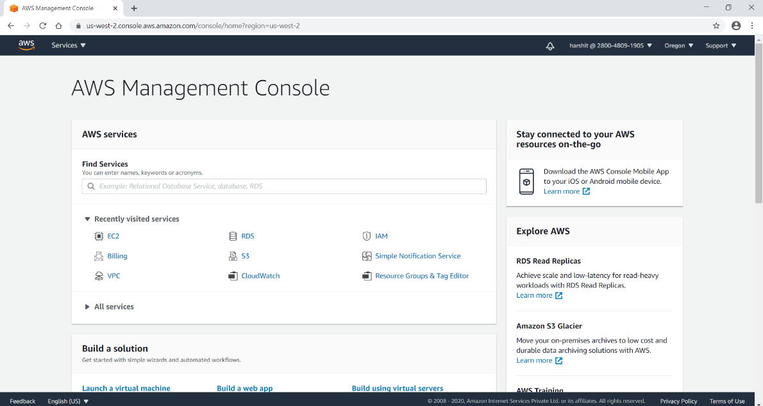

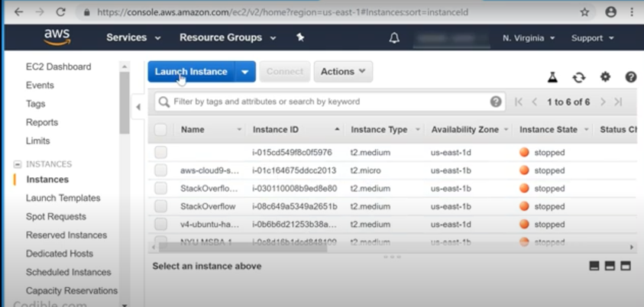

**Step 2:**

**After launching, we have to choose instance type and type of window medium then review and launch, next by choosing default type and launch.**

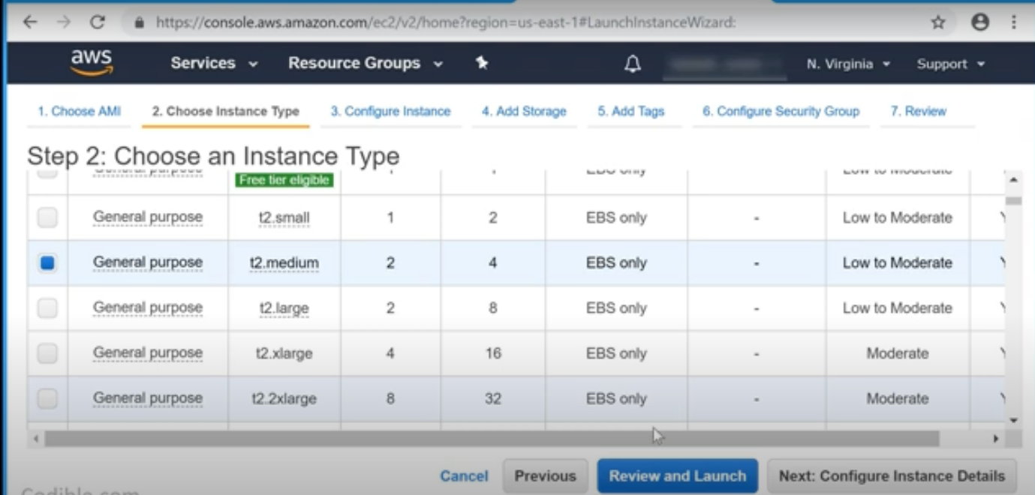

**Step3:**

**Then create a new key pair and download it as perm file.**

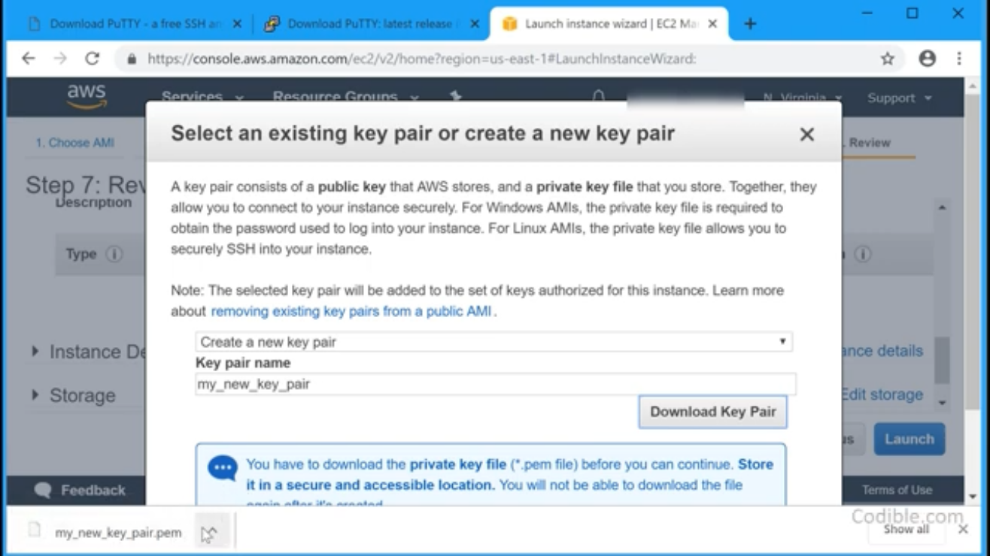

**Step4:**

**Then go ahead to continue and we can view that instance meanwhile its time taking or pending.**

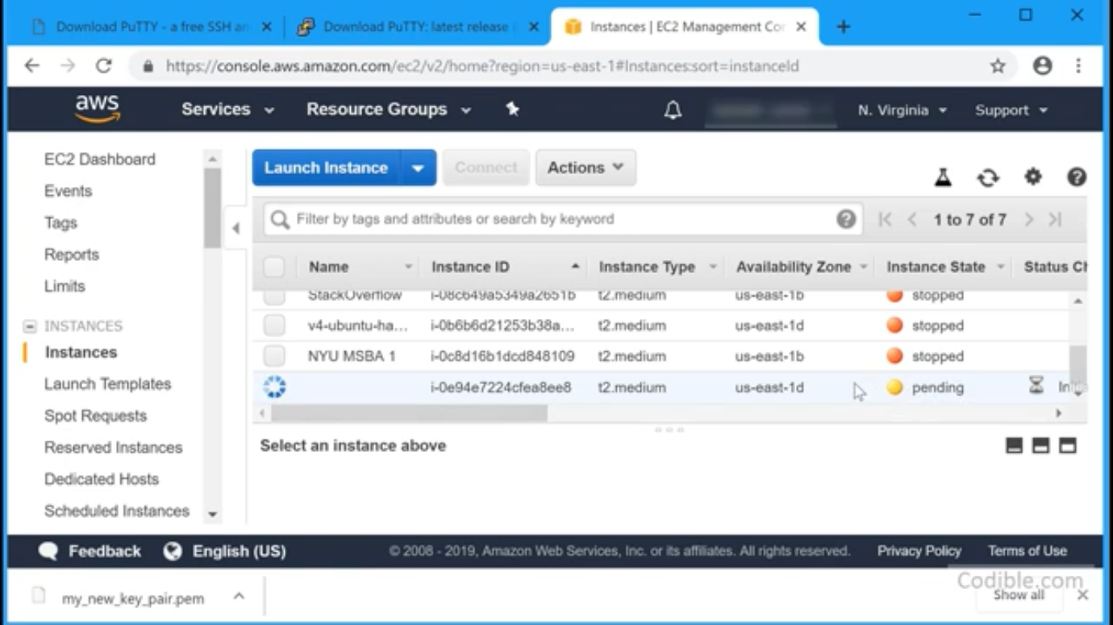

**Step5:**

**Now download PuTTY Software available on** [**https://www.putty.org**](https://www.putty.org)**.Scrolldown to get PuTTY.gen. Meanwhile Copy PuTTY.perm file into the folder into the desktop. Now go toPuTTY gen and read the .perm file into the putty gen by clicking on Load.**

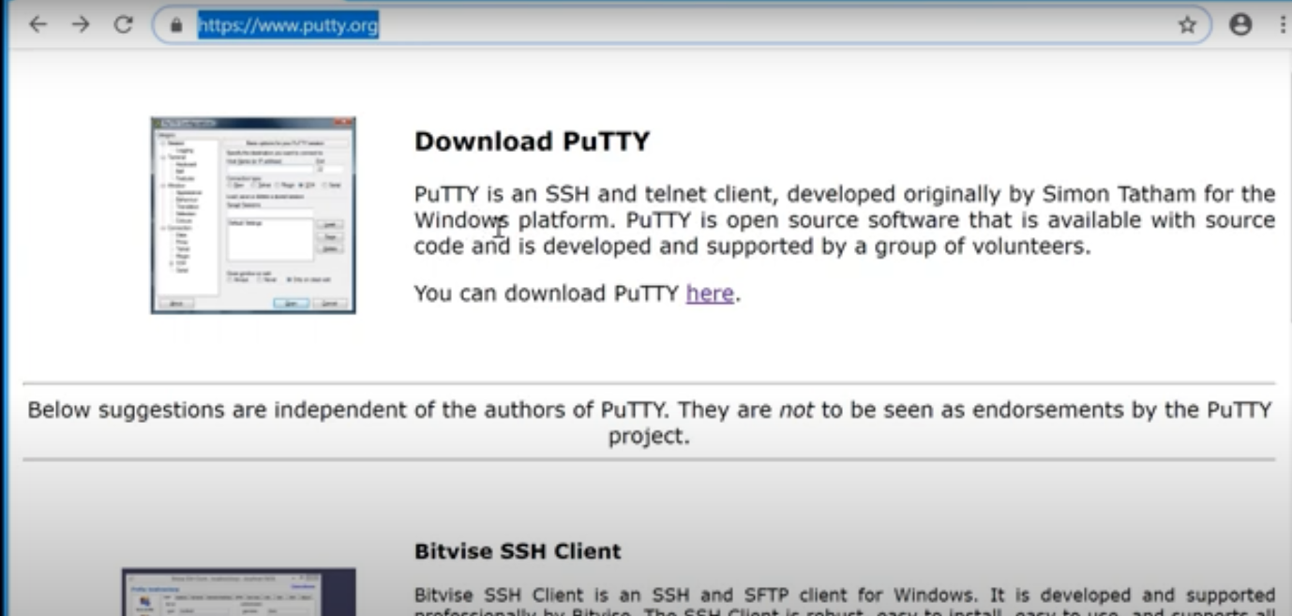

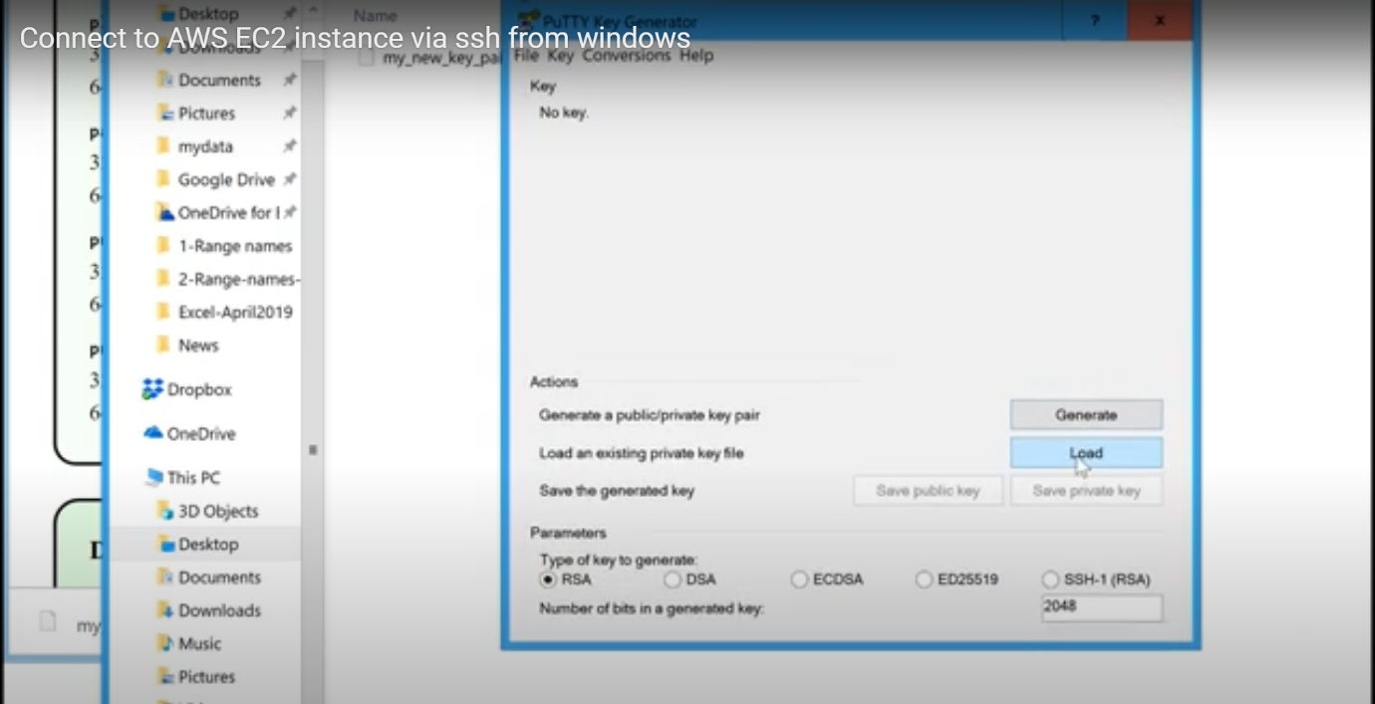

**Step6:**

**Next open the file in the folder and save as the private key with a dialogue box saying yes. Save it with any name as (.ppk)file and save it by closing putty gen.**

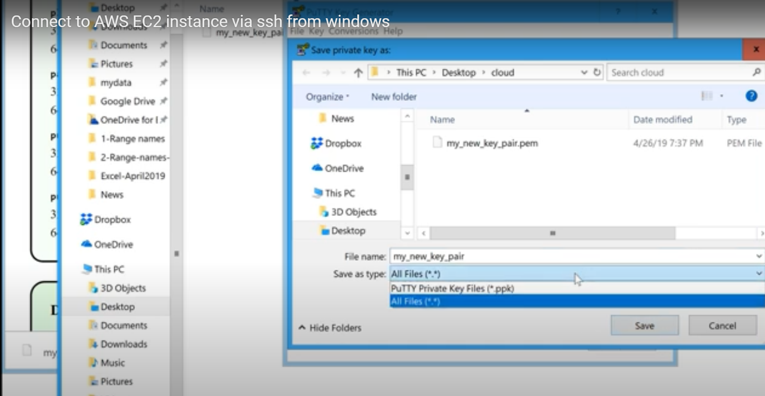

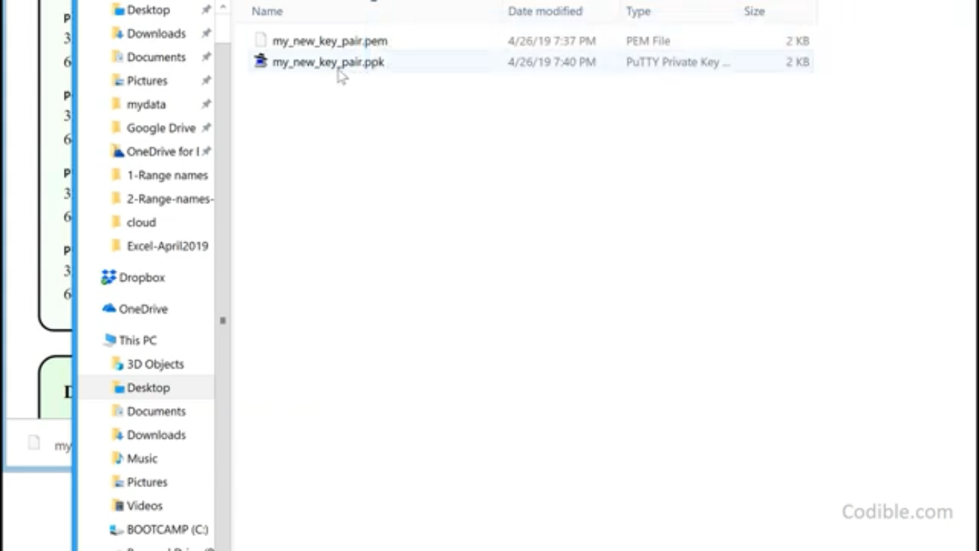

**Step 7:**

**Next start putty where u see instance is running. Select that instance and connect it and you will find a url copy and paste it.**

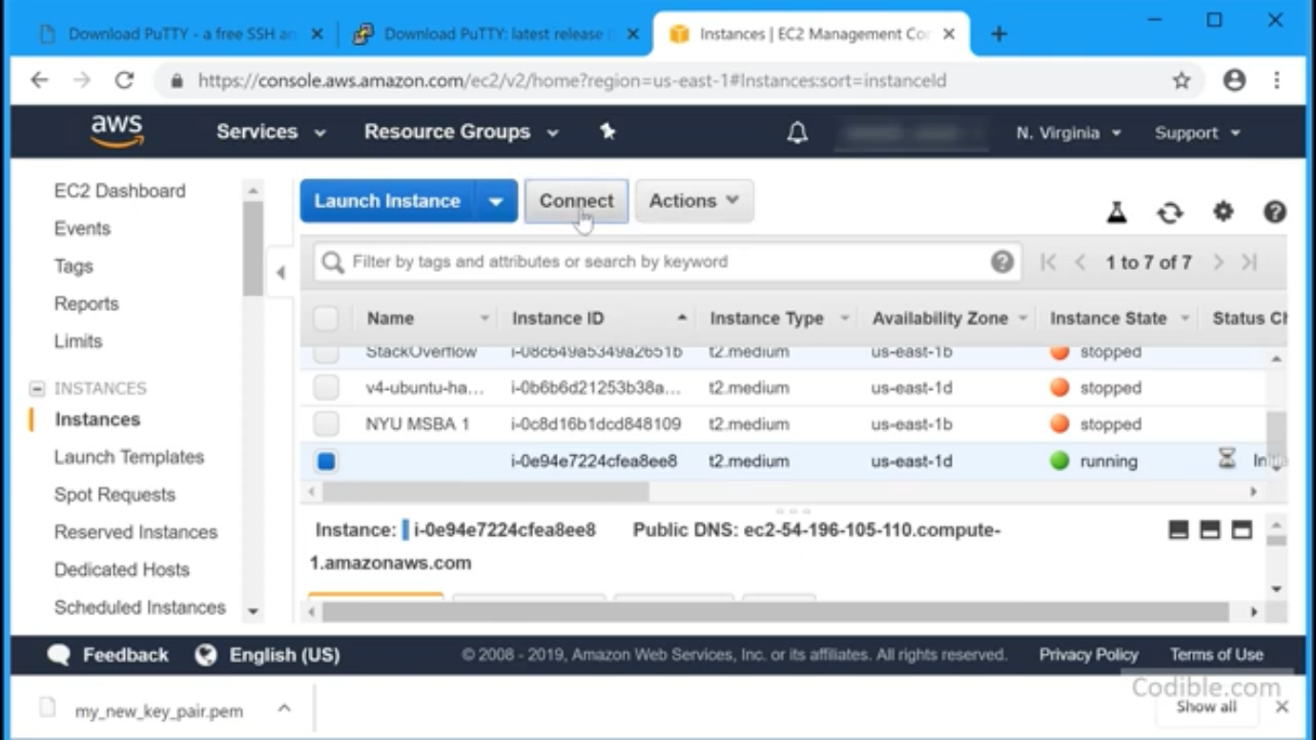

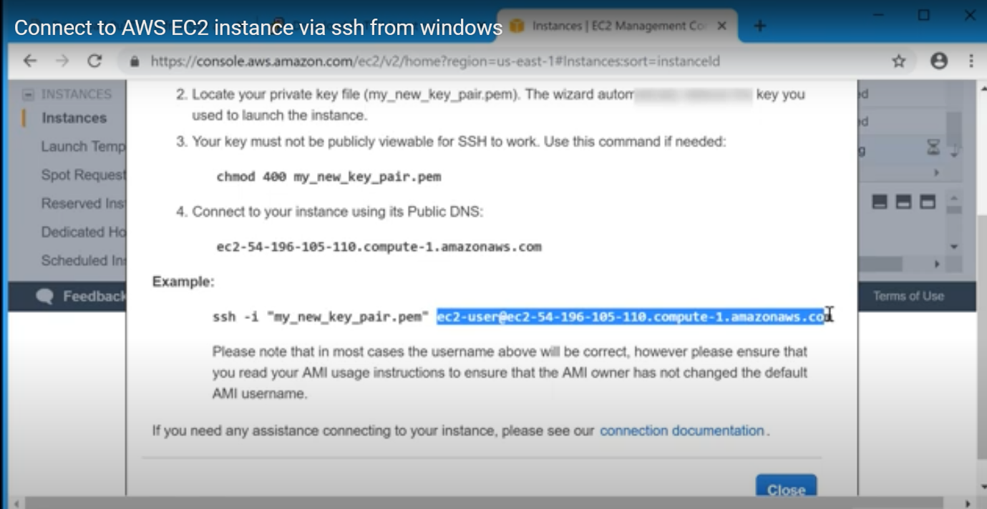

**Step8:**

**On the left side click on SSH and Auth, browse to navigate to the file. Go back to the session and give any name like aws-connect2 and save.**

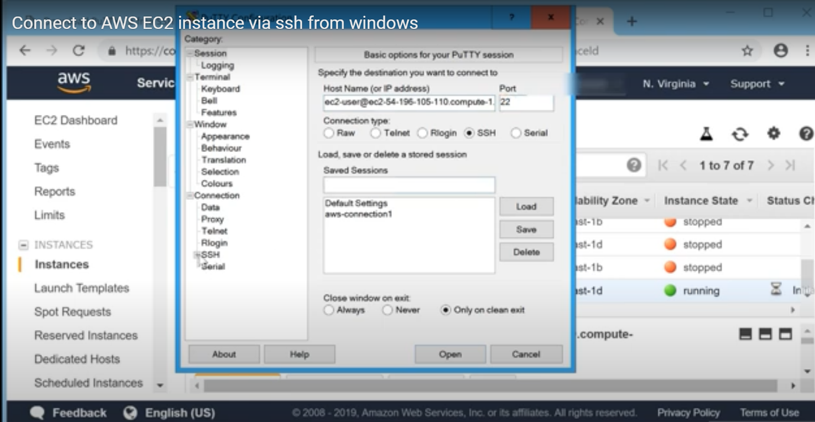

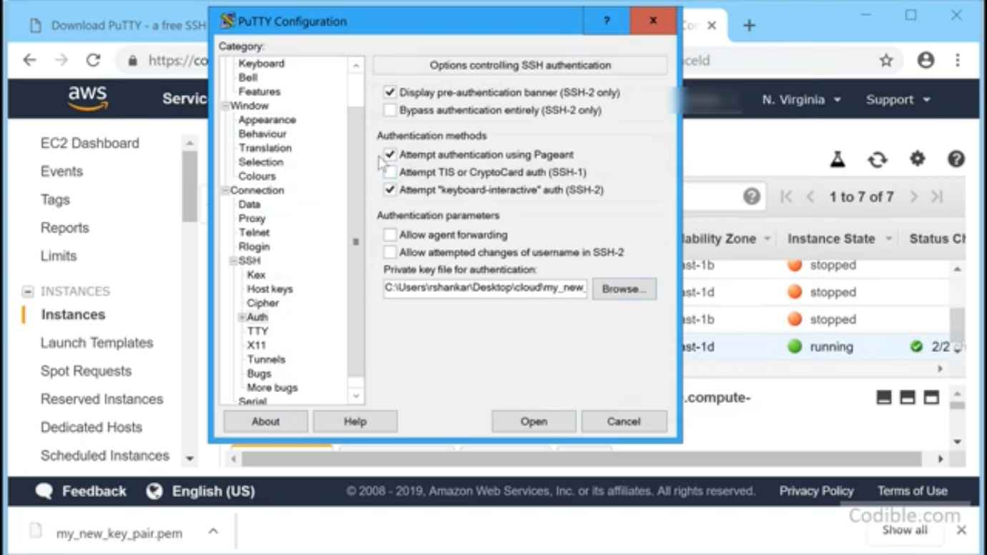

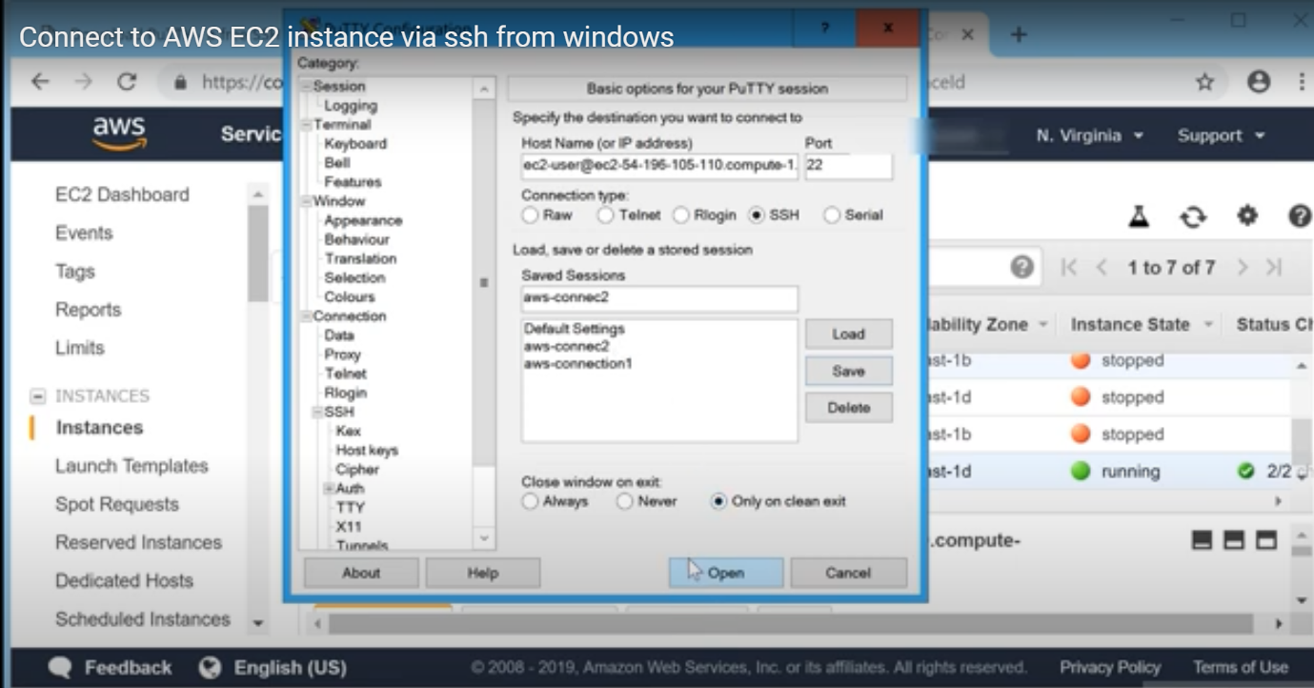

**Step9:**

**Next below you can see open button on a click, with a dialogue box saying YES. Then prompted to command prompt trying to connect to cloud through windows. You have to disconnect by writing EXIT, otherwise you have to be charged.**

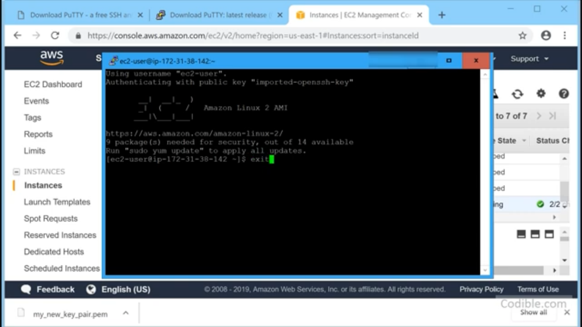

**Step10:**

**Then go to instance check whether it is checked and then go to ACTIONS next to INSTANCE STATE next to STOP. After stopping you can sign-out.**

